Table 4. SR, KA and M_{RR} values for multiple experiments
 | S.no | pressure (MPa) | stand of distance (mm) | traverse speed (mm/min) | Mass flow rate (kg/min) | Surface roughness (µm) | Material removal rate (mm³/sec) | kerf
 | 1 | 220 | 2 | 80 | 0.4 | 4.75 | 119.98 | 2.08
 | 2 | 260 | 1 | 64 | 0.55 | 3.09 | 126.36 | 1.44
 | 3 | 220 | 2 | 80 | 0.45 | 4.46 | 122.4 | 1.98
 | 4 | 140 | 3 | 96 | 0.55 | 5.02 | 111.57 | 2.25
 | 5 | 300 | 1 | 96 | 0.35 | 3.84 | 126.63 | 1.75
 | 6 | 140 | 1 | 64 | 0.35 | 5.04 | 97.63 | 2.25
 | 7 | 220 | 2 | 72 | 0.45 | 4.38 | 121.6 | 1.95
 | 8 | 140 | 3 | 64 | 0.55 | 4.61 | 109.81 | 2.09
 | 9 | 280 | 2 | 80 | 0.45 | 4.14 | 137.08 | 1.83
 | 10 | 300 | 1 | 64 | 0.35 | 3.5 | 117.28 | 1.59
 | 11 | 300 | 3 | 96 | 0.35 | 3.97 | 143.3 | 1.86
 | 12 | 220 | 2 | 88 | 0.45 | 4.63 | 125.7 | 2.04
 | 13 | 140 | 3 | 96 | 0.35 | 5.56 | 106.95 | 2.57
 | 14 | 300 | 3 | 96 | 0.55 | 3.62 | 148.41 | 1.64
 | 15 | 140 | 1 | 64 | 0.55 | 4.08 | 102.02 | 1.86
 | 16 | 180 | 2 | 80 | 0.45 | 4.75 | 115.2 | 2.15
 | 17 | 220 | 2 | 80 | 0.45 | 4.46 | 122.4 | 1.98
 | 18 | 220 | 1.5 | 80 | 0.45 | 4.41 | 119.69 | 1.96
 | 19 | 300 | 3 | 64 | 0.55 | 3.42 | 145.92 | 1.52
 | 20 | 220 | 2 | 80 | 0.5 | 4.27 | 131.74 | 1.93
 | 21 | 220 | 2.5 | 80 | 0.45 | 4.67 | 132.71 | 2.05
 | 22 | 140 | 1 | 96 | 0.35 | 5.36 | 99.7 | 2.43
 | 23 | 300 | 1 | 96 | 0.55 | 3.29 | 140.98 | 1.48
 | 24 | 220 | 2 | 80 | 0.45 | 4.46 | 122.4 | 1.98
 | 25 | 140 | 1 | 96 | 0.55 | 4.53 | 104.26 | 2.08
 | 26 | 140 | 3 | 64 | 0.35 | 5.23 | 103.66 | 2.34
 | 27 | 300 | 3 | 64 | 0.35 | 3.80 | 139.85 | 1.73

Output | Ridge Hyper  parameter | Ridge R² | RF Hyper  parameter | RF R² | XGB Hyperparameter | XGB R² | NN Hyperparameter | NN R²
surface Roughness | {'alpha': 1, } | 0.926 | {n_estimators=100, max_depth=10} | 0.971 | {n_estimators=100, max_depth=5, learning_rate=0.05} | 0.997 | {'hidden_layer_sizes': architecture=(6,4,3), alpha=0.001, learning_rate=0.0} | 0.925
MRR | {'alpha': 1, } | 0.940 | {'n_estimators':100,  'max_depth':10} | 0.973 | {'n_estimators':100,  'max_depth':5,  'learning_rate':0.05,  'subsample':0.8} | 0.997 | {'hidden_layer_sizes:'  architecture=(8,5,4), alpha=0.001, learning_rate=0.01} | 0.946
Kerf Angle | {'alpha': 1, } | 0.967 | {'n_estimators':100  ,'max_depth':10} | 0.907 | {'n_estimators':100,  'max_depth':5  ,'learning_rate':0.05,  'subsample':0.8} | 0.996 | {'hidden_layer_sizes': architecture=(6,4,2), alpha=0.001, learning_rate=0.01} | 0.850
Table 5: Hyperparametrs for optimized models.

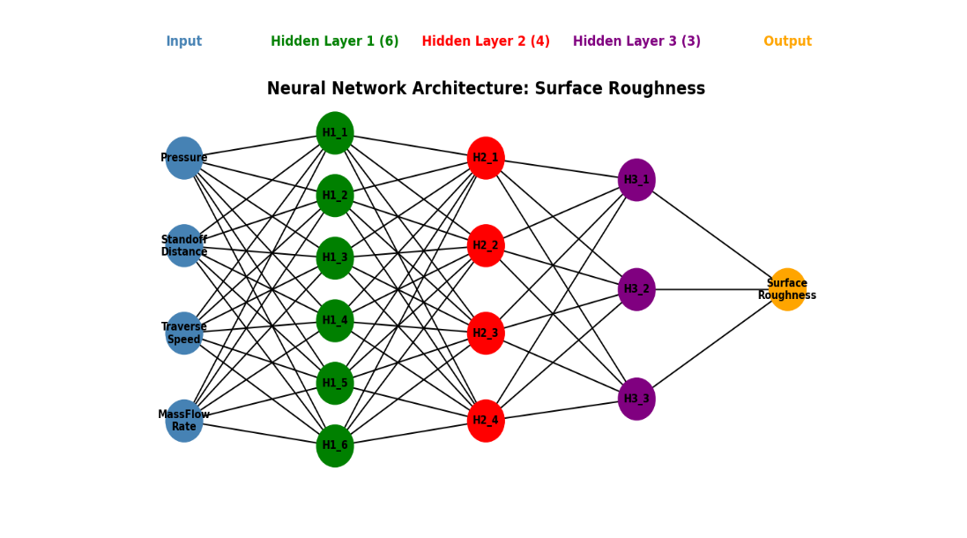
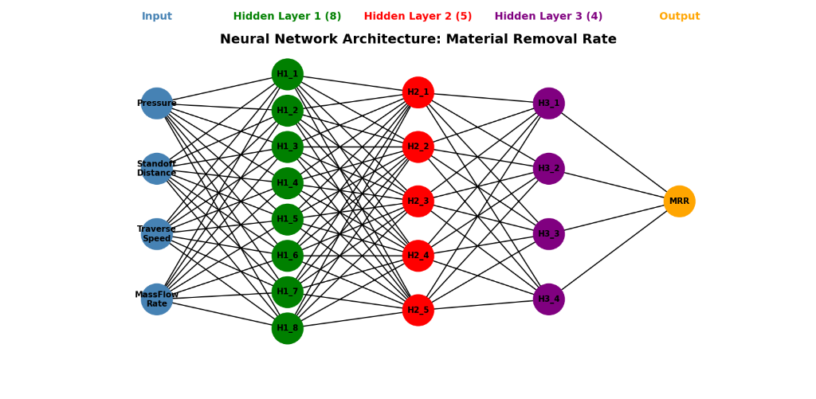

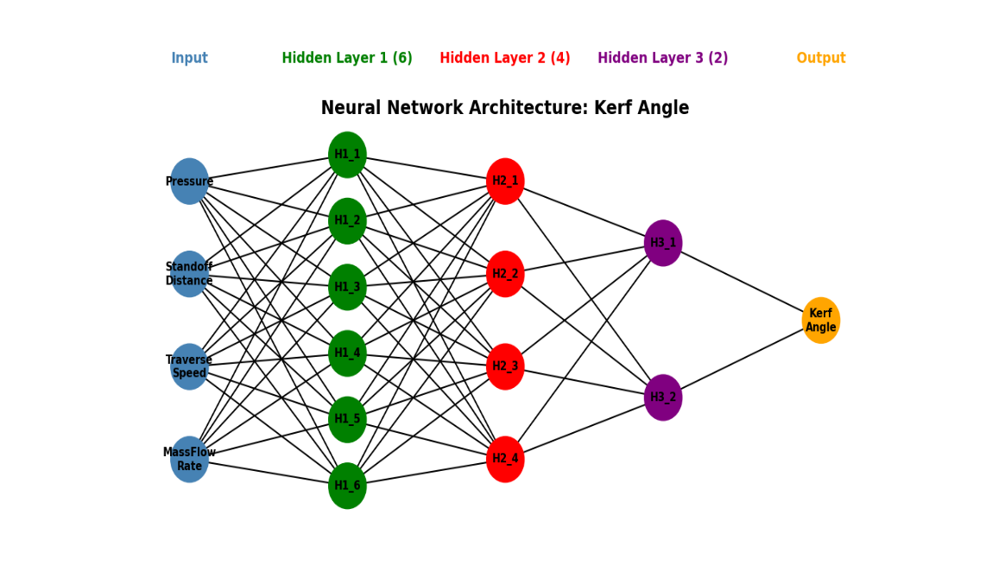

Fig. 5. architecture for SR, MRR, and kerf angle models step 3: Ensemble Model Creation.
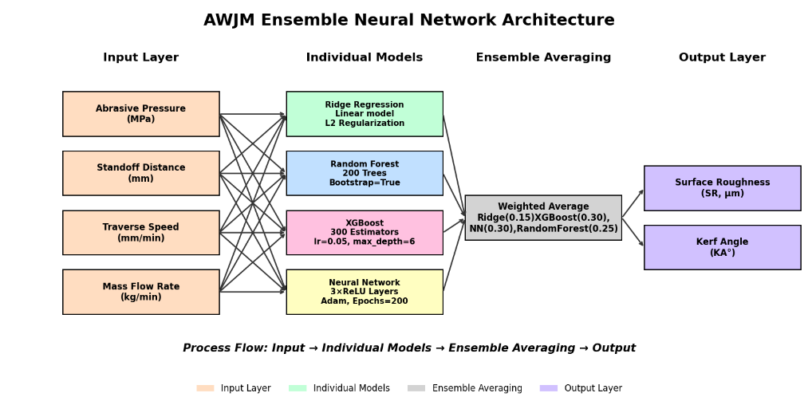

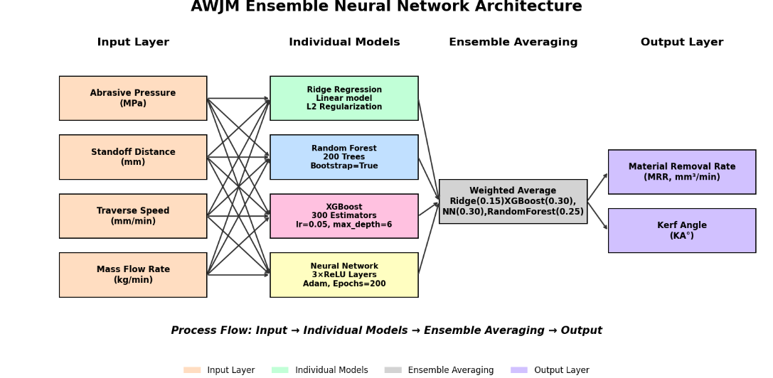

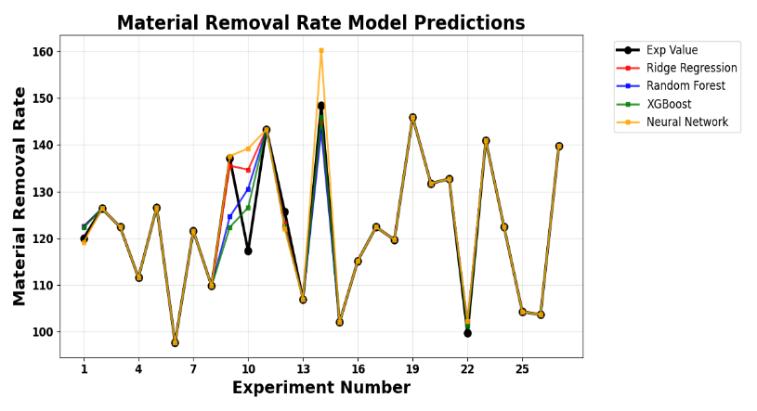
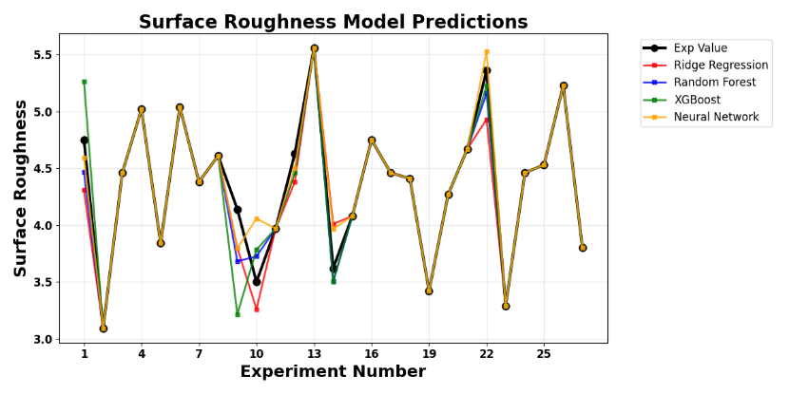

- (b)
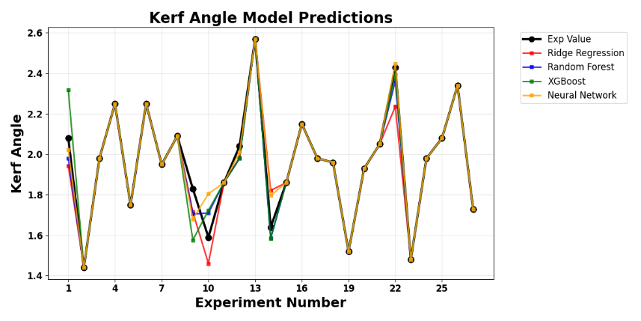

(c)
Fig. 7. Validation of each model with experimental value
Table 6: Ensemble Model performance.
Ensemble Model Performance Summary
Target | RMSE | MAE | R²
Surface Roughness | 0.0768 | 0.0563 | 0.9484
Material Removal Rate | 2.9824 | 2.5181 | 0.9571
Kerf Angle | 0.0345 | 0.0294 | 0.9845

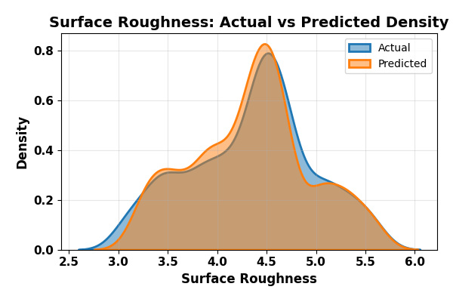
SURFace roughness:
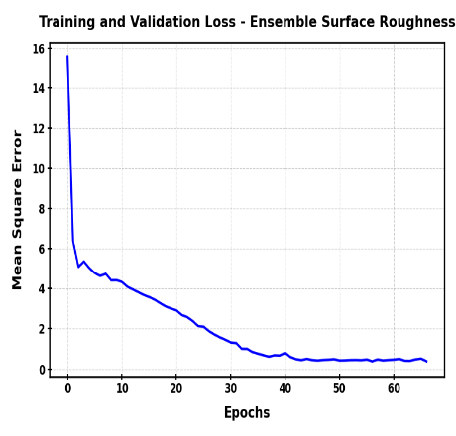
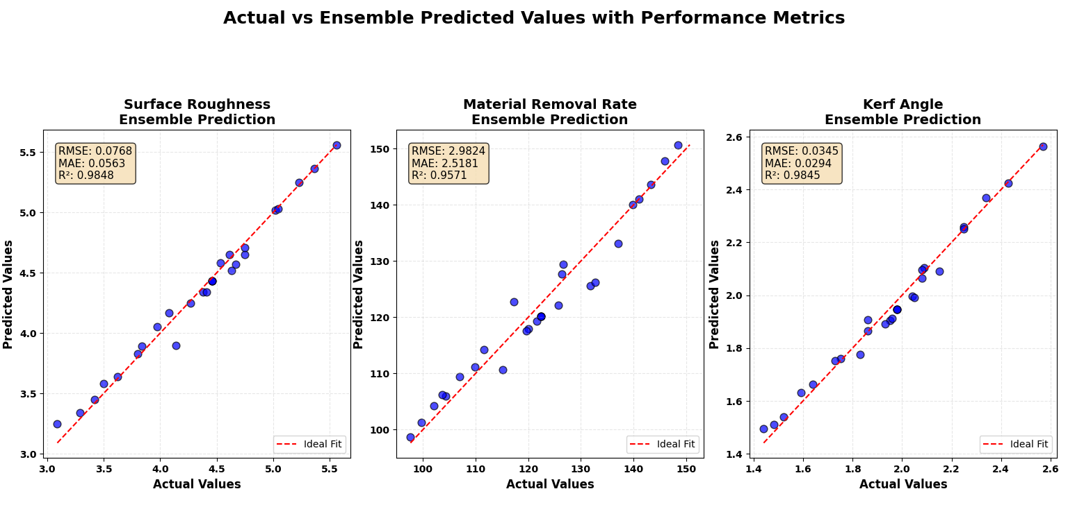

(a) (b) (c)

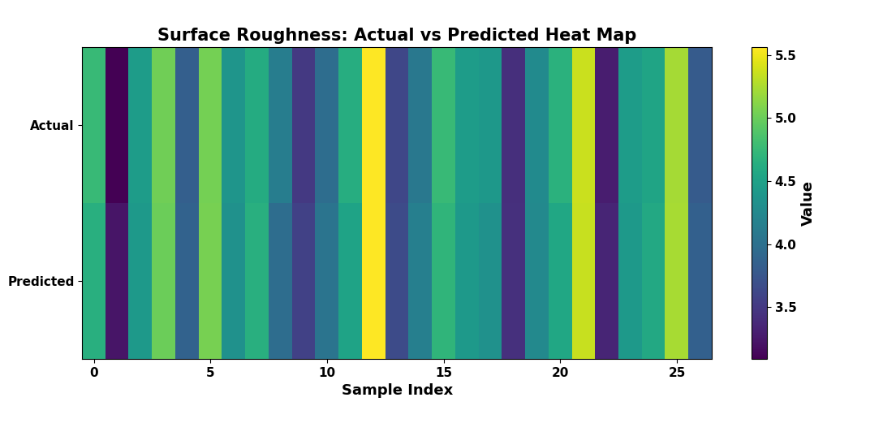
Fig. 8. Ensemble Surface Roughness Model Performance (a) Training and Validation Curve (b) Actual vs Predicted value (c) Density curve (d) Heat map.

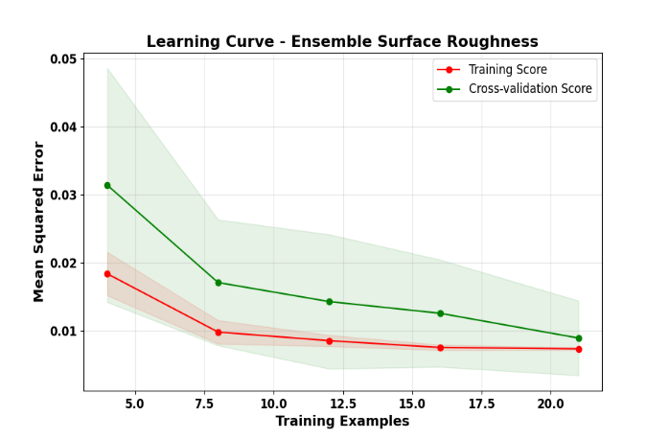
(d)

Fig. 11. Learning curve for Cross-validation Surface Roughness

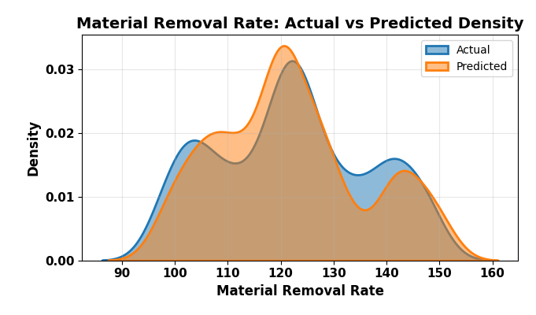
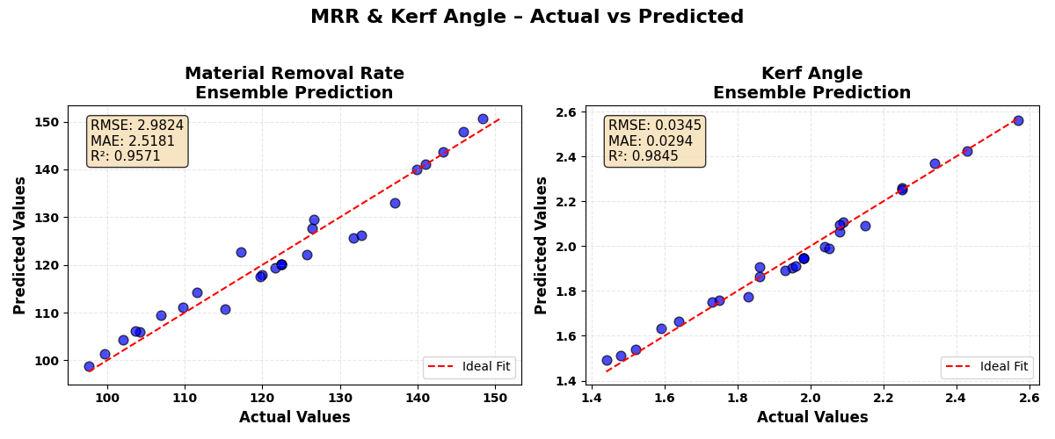
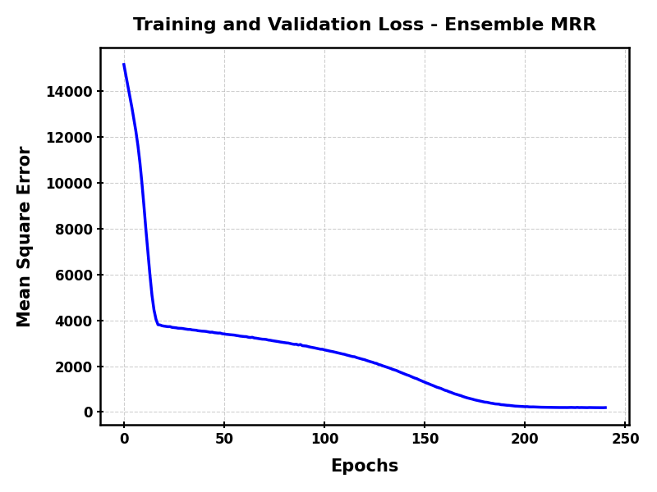
Material Removal Rate

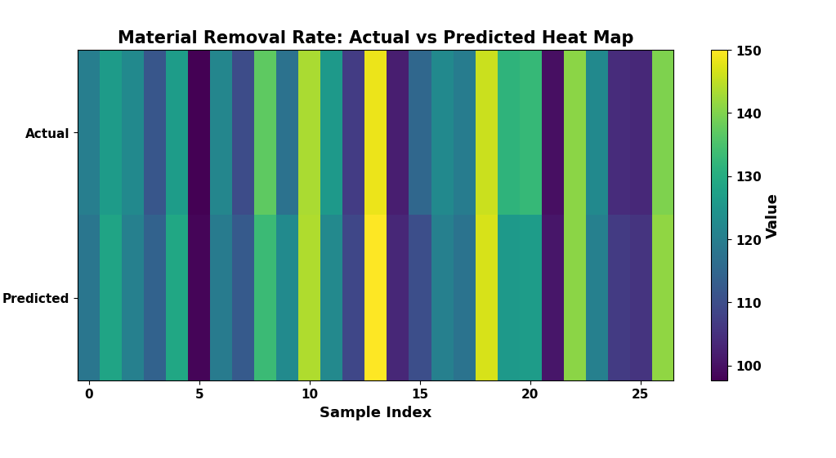
- (b) (c)

Fig. 8. Ensemble Material Removal Rate Model Performance (a) Training and Validation Curve (b) Actual vs Predicted value (c) Density curve (d) Heat map.
(d)

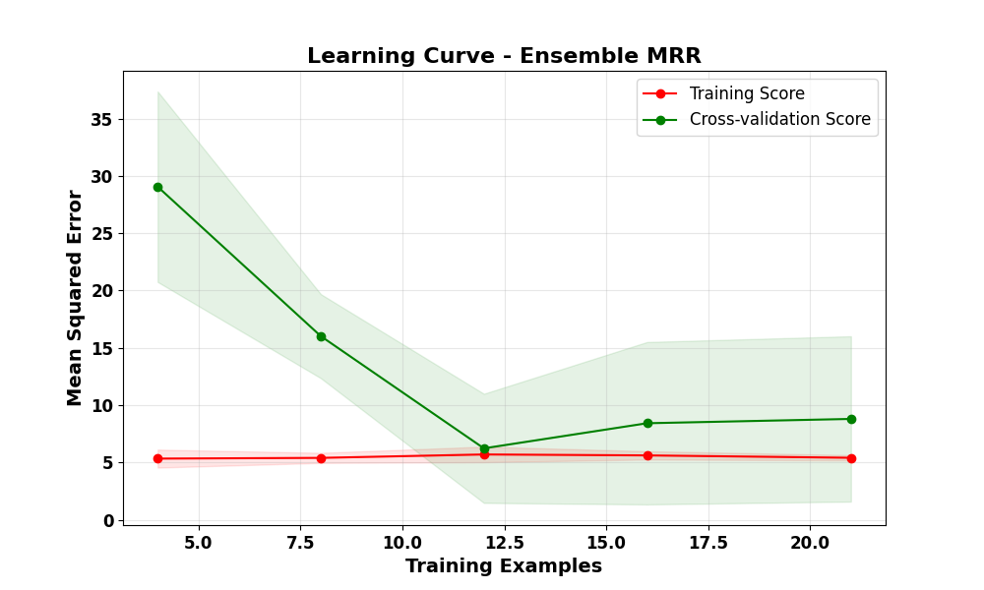
Fig. 11. Learning curve for Cross-validation Material Removal Rate.

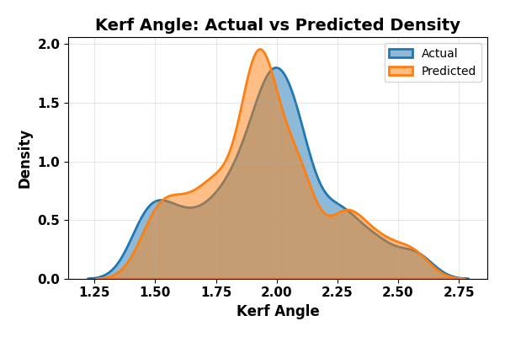

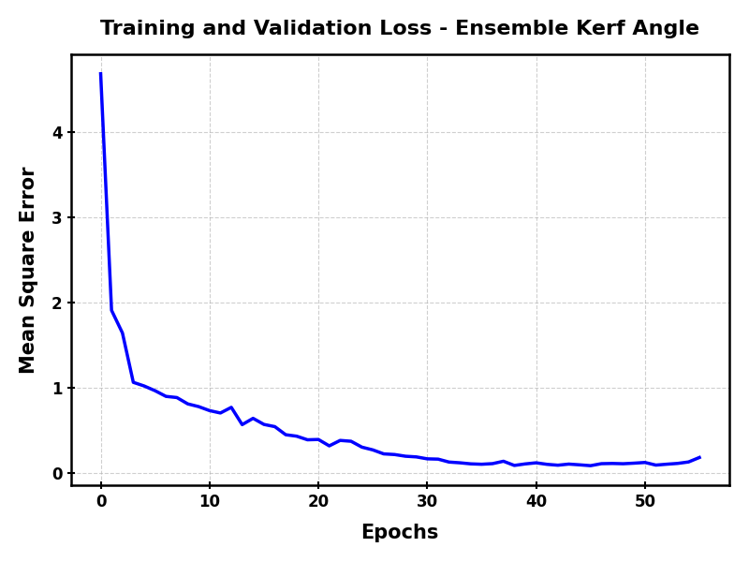
KERF ANGLE

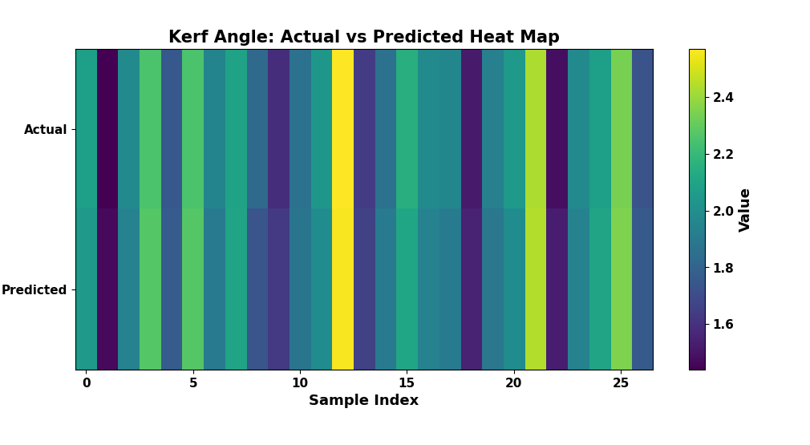
(a) (b) (c)

Fig. 8. Ensemble Kerf Angle Performance (a) Training and Validation Curve (b) Actual vs Predicted value (c) Density curve (d) Heat map.

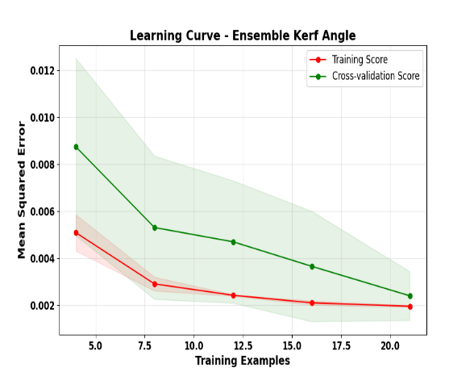

Fig. 11. Learning curve for Cross-validation Kerf Angle

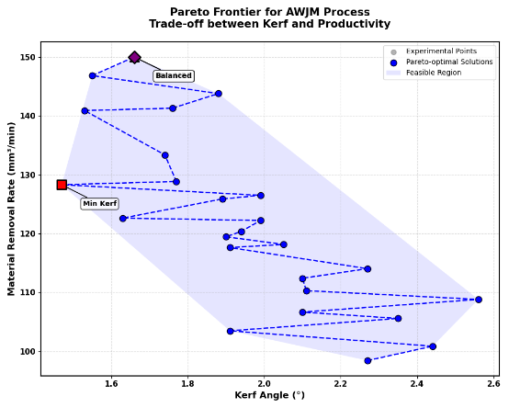
Table 3: Optimal Process Parameter Settings for Different Objectives
Parameter | Min Kerf | Max MRR | Balanced
Pressure (MPa) | 260 | 300 | 300
Standoff Distance (mm) | 1 | 3 | 3
Traverse Speed (mm/min) | 64 | 96 | 96
Mass Flow Rate (kg/min) | 0.55 | 0.55 | 0.55
Expected Kerf (°) | 1.47 | 1.66 | 1.66
Expected MRR (mm³/min) | 128.31 | 150.03 | 150.03

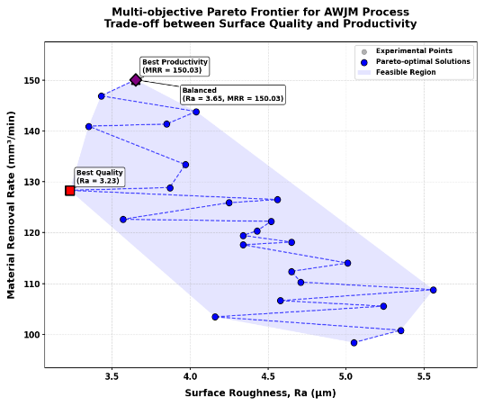
Table 3: Optimal Process Parameter Settings for Different Objectives
Parameter | Min Ra | Max MRR | Balanced
Pressure (MPa) | 260 | 300 | 300
Standoff Distance (mm) | 1 | 3 | 3
Traverse Speed (mm/min) | 64 | 96 | 96
Mass Flow Rate (kg/min) | 0.55 | 0.55 | 0.55
Expected Ra (μm) | 3.23 | 3.65 | 3.65
Expected MRR (mm³/min) | 128.31 | 150.03 | 150.03

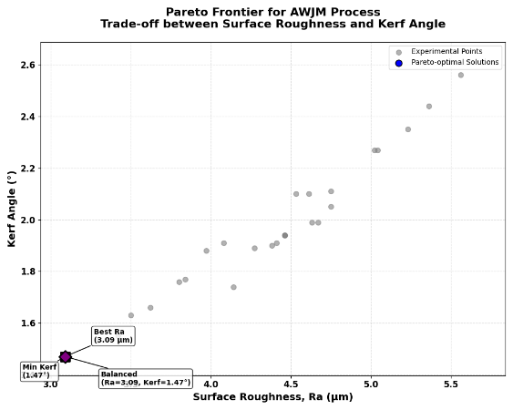
Table 3: Optimal Process Parameter Settings for Different Objectives
Parameter | Min Ra | Min Kerf | Balanced
Pressure (MPa) | 260 | 260 | 260
Standoff Distance (mm) | 1 | 1 | 1
Traverse Speed (mm/min) | 64 | 64 | 64
Mass Flow Rate (kg/min) | 0.55 | 0.55 | 0.55
Expected Ra (μm) | 3.09 | 3.09 | 3.09
Expected MRR (mm³/min) | 1.47 | 1.47 | 1.47

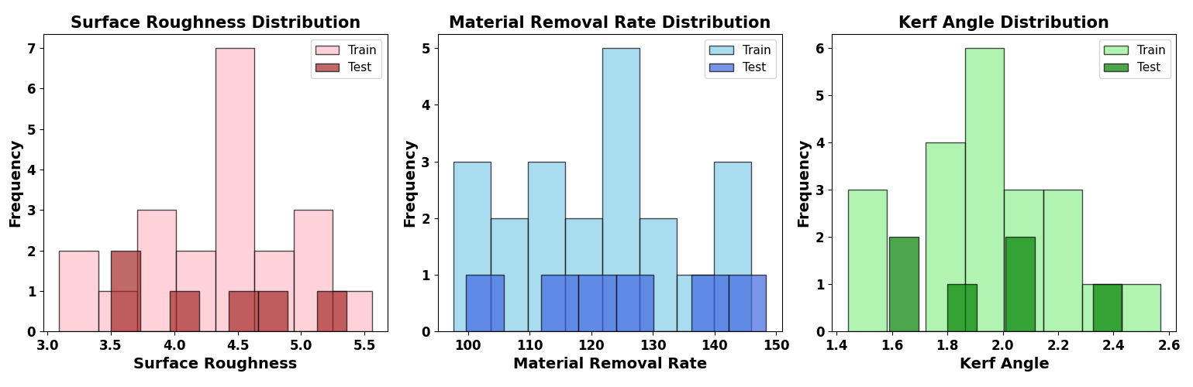
Distribution:
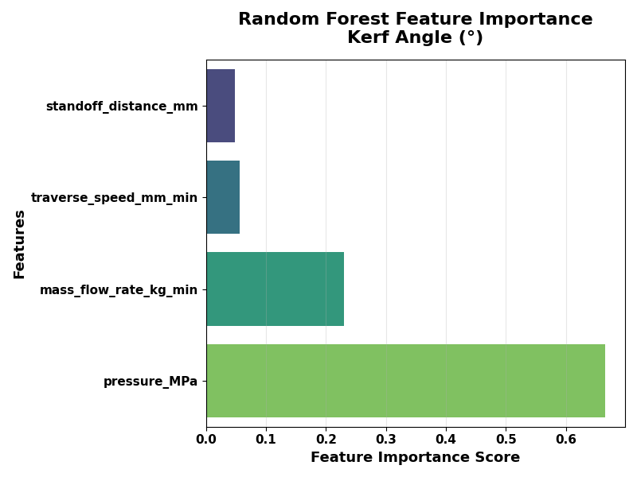
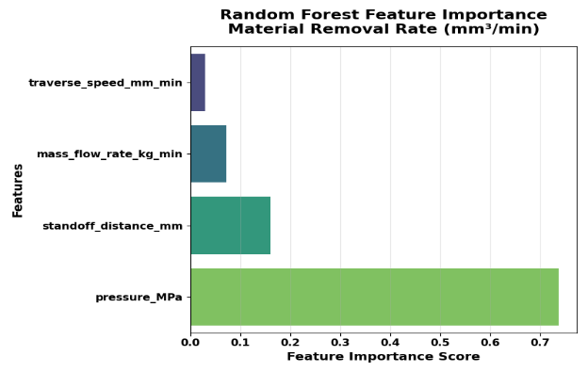
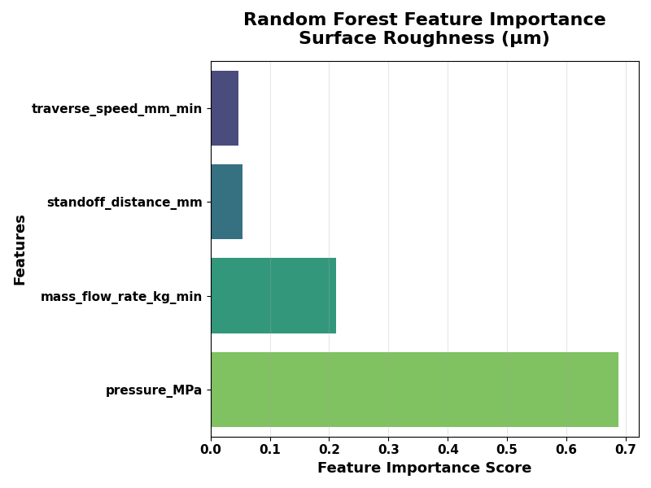
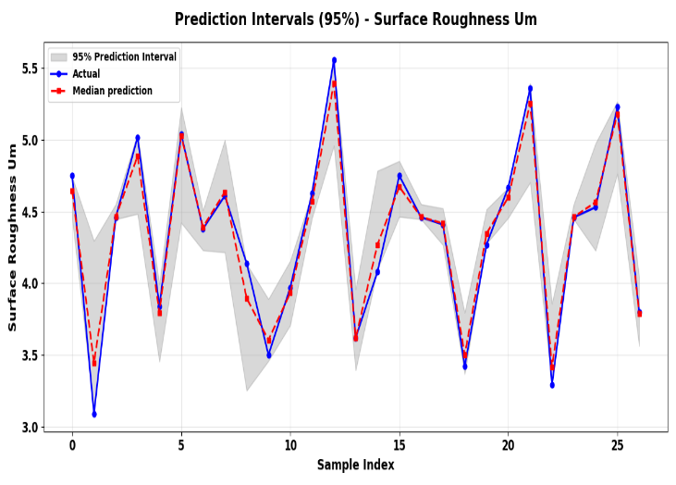
BOOSTRAP
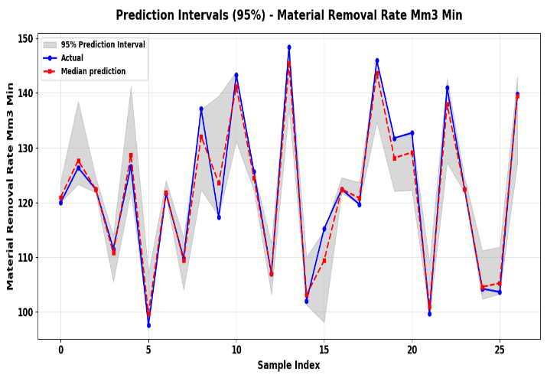

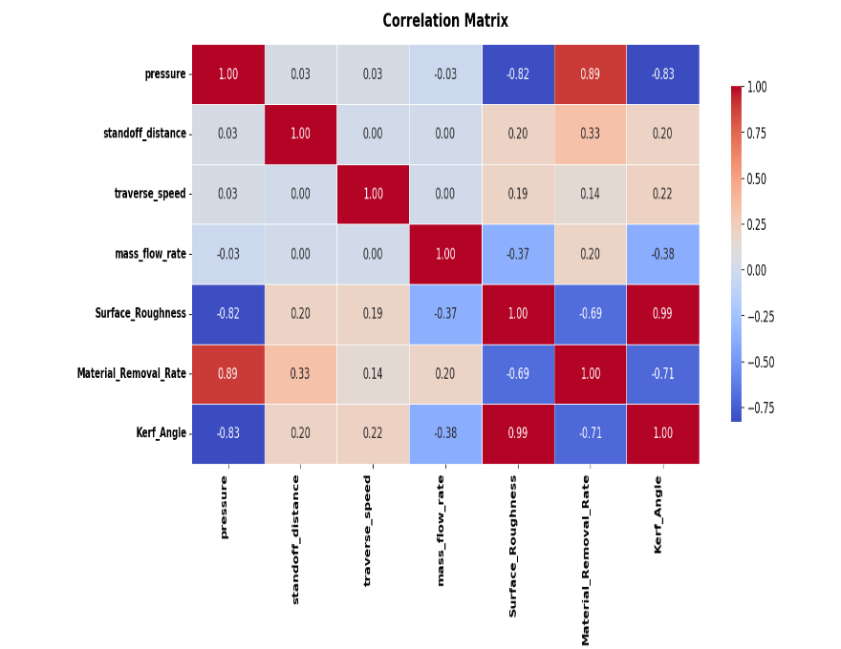
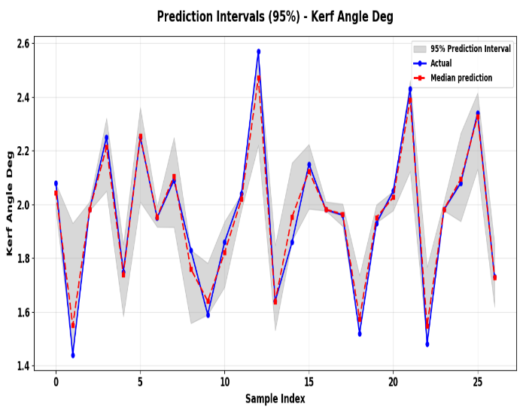

HYBRID Ensemble:

